OLYMPIC GAMES

- How many Olympic Games have been held in each season (Summer vs. Winter) ? 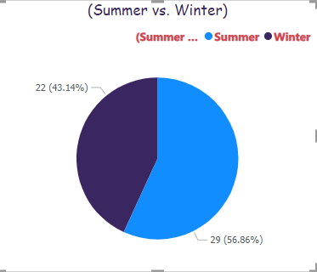
Ans- we have used pie chart to show the percentage for the number of olympic games have been held in each season. This allows us to easily see how many games have been held in summer compared to winter.

- What is the distribution of games across different decades?

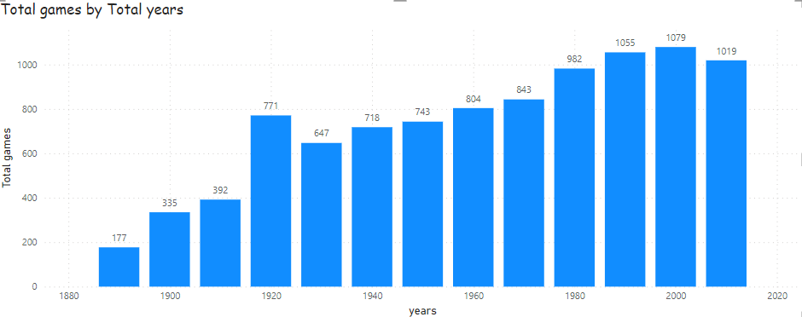Ans- as per this bar chart showing the total no of game over decade (total year) for the Olympic games.
- Which cities have hosted the most Olympic Games?
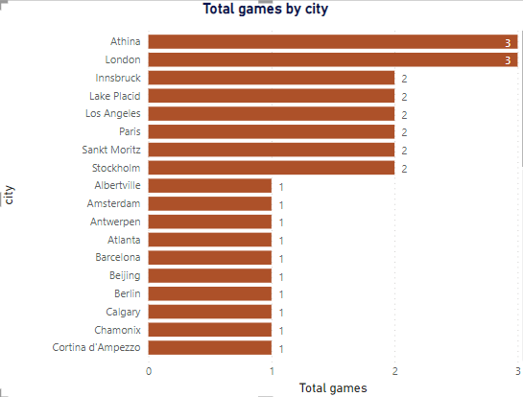

Ans- this composition is showing the top city which have hosted the most Olympic games

- What is the distribution of sports between Summer and Winter Olympics?
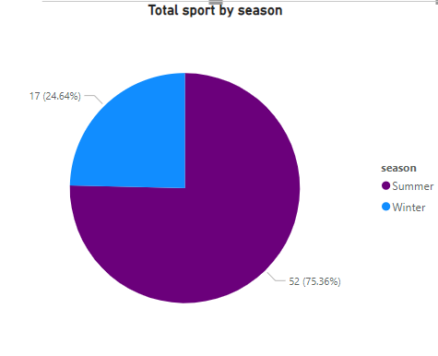

Ans- this report is the distribution of sports between the summer and winter
Olympics .this show clear view that how many games has held in both season.
- Which sports have the highest number of events in the Olympics?
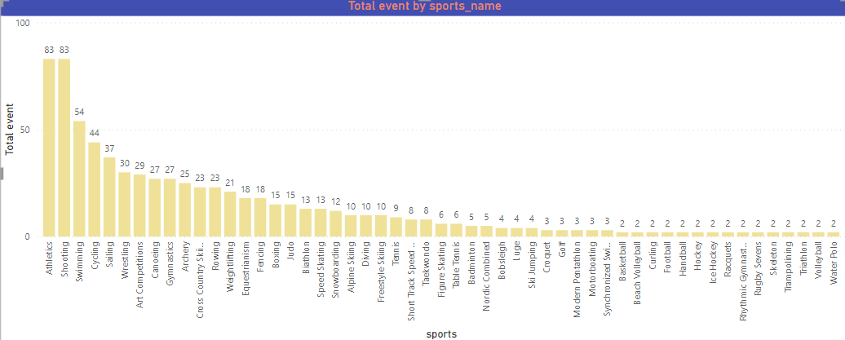

Ans- this column chart is is showing the highest number events held for different sports in the Olympics.

- How has the participation in each sport evolved over time?
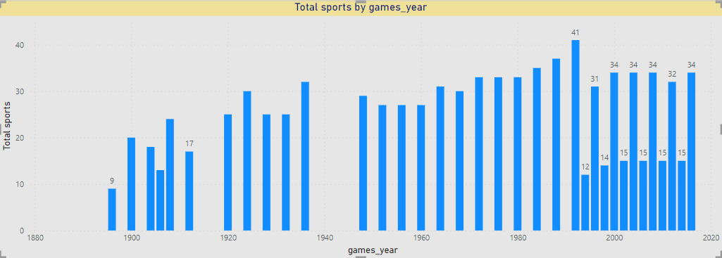

Ans- we shown this report through this bar chart for better view as we have shown the total sport have been held through this year.

- many events are there in each sport?

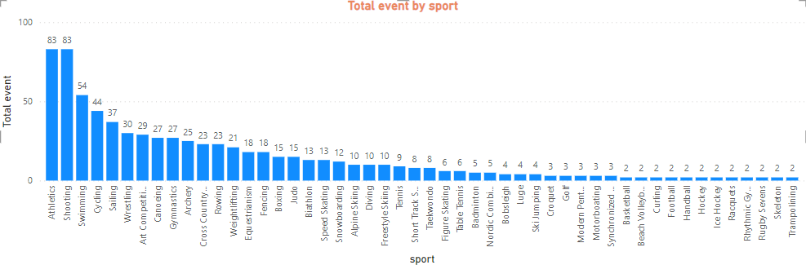
Ans-
As per this report we have used stacked column chart we get a clear view for the total number of events been held for different sports .

- What is the distribution of events by gender (Men, Women, Mixed)?
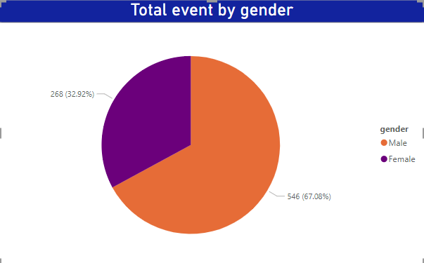

Ans- In this pie chart we have shown the distribution of male and female , as we can see male percentage are more than females.

- How has the number of events changed over time?
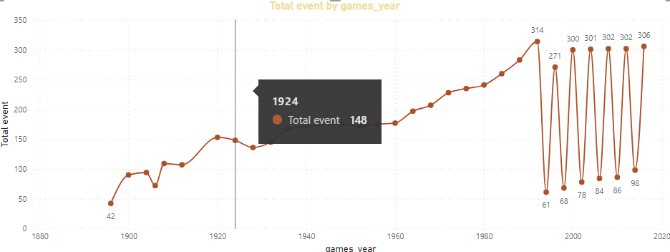

Ans- this line chart is showing that how the total no of events over the total year changes through decades.

- What is the distribution of participants by gender?
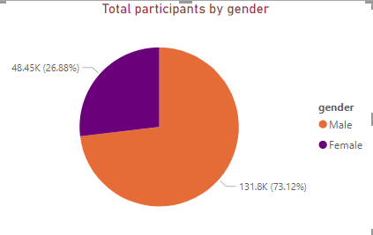

Ans-
As we can see through the report the distribution of participation over gender , male have more number of participants in compare to females.
- Which countries have the highest number of participants in the Olympics?
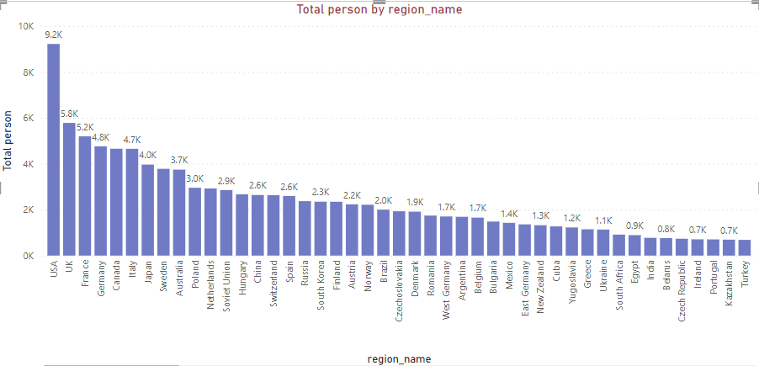

Ans - This bar chart is showing the highest number of participants in the Olympics , like in the top place
USA holding the position.

- How does the age distribution of participants vary across different games?
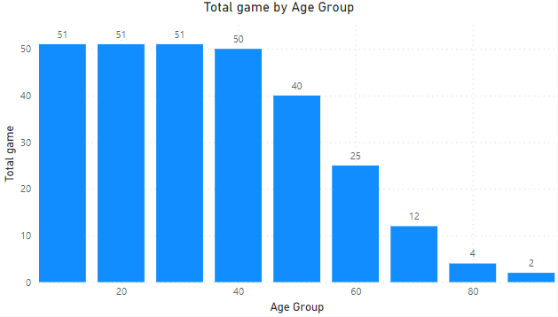

Ans-
As we can see staked bar chart the age distribution of participants vary across different games,
Its shows the total game distributed by the age group .
- How many medals have been awarded in each Olympics?
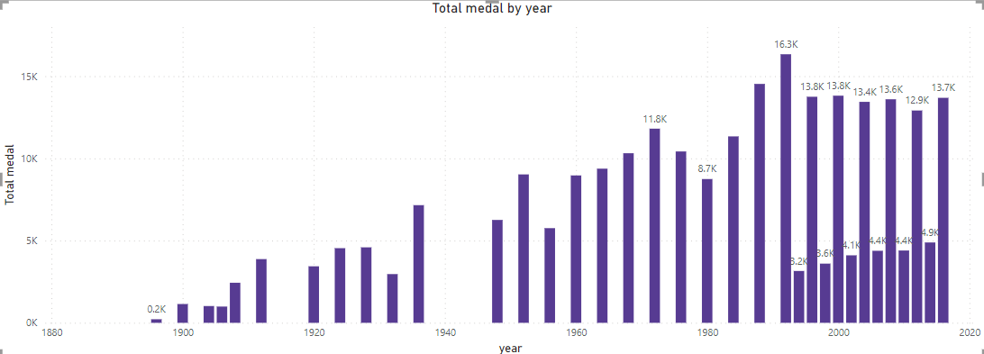

Ans-
This report is showing the distribution of the awarded medal through different year in each Olympics.

- Which countries have the highest number of gold medals?
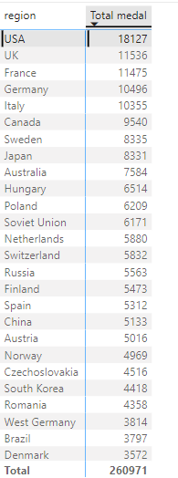
Ans-
This multi-row card is show the country which obtain the highest number of gold medals in the Olympic game through year.

- How does the medal distribution vary across different sports?
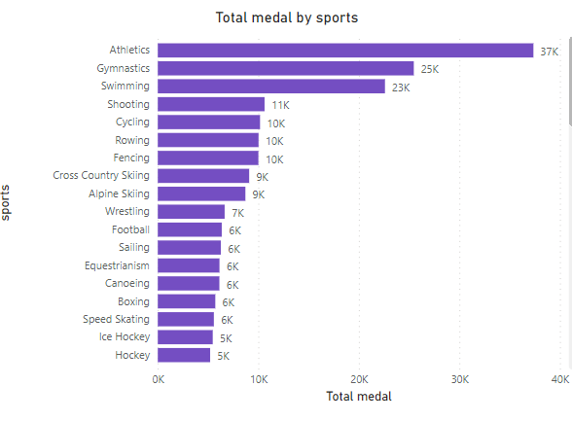
Ans- as we can the athletics is at the top of the sport is the medal distribution through different sports.

- How many regions or NOCs participate in each Olympic Games?
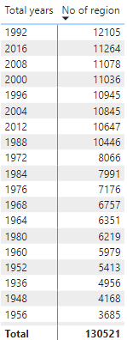
Ans-
As per the report shows we can see the no of participants through different region for each Olympic.
- Which regions have the highest number of participants in the Olympics?
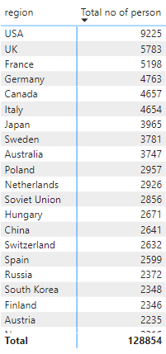
Ans- this report is showing the highest number of participants in the Olympics, USA has the highest no of participants holding the top spot for the decade .

- What is the distribution of medals among different regions?
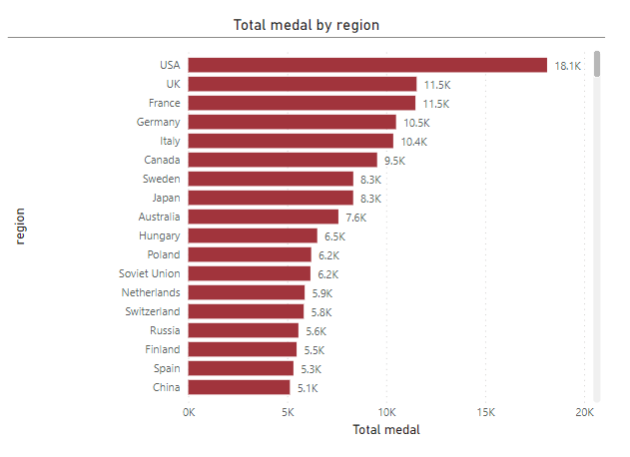
Ans- as per this power bi report we can visualise the distribution of medals among different regions
USA has the highest medal by region for the decades.

